HOW TO MANUAL



iPAD SYSTEM

Contents

**Overview**

* Connecting to the system
* Selecting a panel

**Start up /Shut down procedures**

* Lighting
* Audio
* Vision
* Maglocks

**Show Operations**

* Operations window
* During showtimes
* Alerts
* Alert window
* Relaxed performances
* Syncing

**Show Stops/Pause procedures**

* Pausing a show
* Emergency Stop
* Reset after an emergency stop

Overview:

The iPad system we use at Bluey’s World is a wireless control interface that connects to our show control software (Alcorn McBride) using the software Winscript. These iPads are custom designed to operate, activate and deactivate all necessary show systems relevant to us. This includes but is not limited to show control, lighting, audio, vision and automation.

Generally, the iPads have 3 purposes:

* Operate as a way for the experience team (characters) to communicate without breaking character for any requirements.
* Used in rehearsals outside of shows to operate sequences and rooms.
* Used by technical staff to monitor, operate and control show control equipment and accessories.

The unlock code for an iPad is: **400701**

**Connecting to the system:**

The Winscript iPad system is an IOS application called “Show Touch” that can be downloaded on any apply product (currently). Each iPad on site has this installed. Simply click on the app to open. For a windows computer – You can access Show Touch via the Winscript software. To do this you need to navigate to [tools][show touch].

When the app is open, it will ask you to connect to the system. To do this, you need to type on the show controller’s IP address.

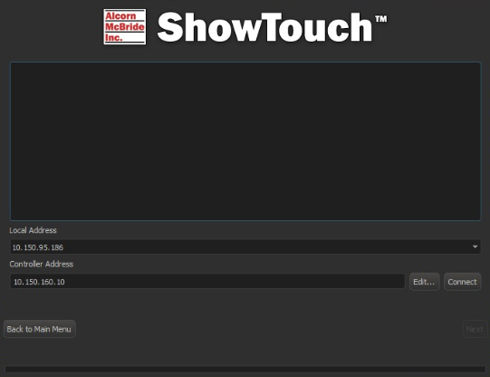

Our show controller’s IP address is: **10.150.160.10**

Once you have type this in, click connect. A green tick and loading bar will illuminate communicating to you that it has found the show file and loaded. One this has loaded, click next.

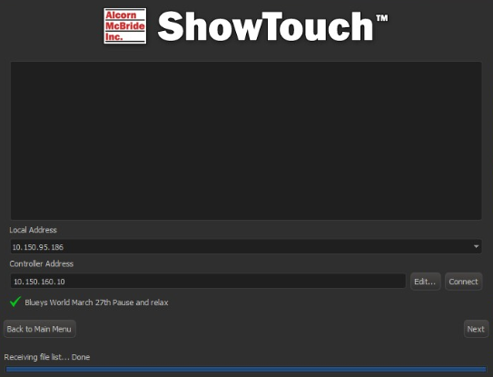

**Selecting a panel:**

Once the panel list has loaded, you can select a panel by clicking on the name and pushing next.

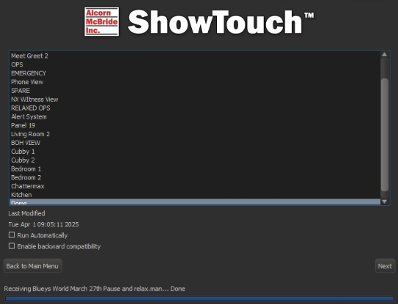

If you want to change what panel you are viewing, all you need to do is tap on the screen and hold for about 8-10 seconds and the app will take you back to the panel list (image above).

**Start up /Shut down**

To commence your day, you will need to navigate to the **OPS panel**. The iPad has a technical button on the main operations page that will navigate to external devices for audio, vision, lighting and automation.

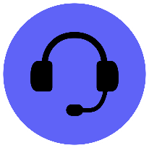

This setup is designed so the show control sends messages via OSC to other devices. We use the iPad to trigger sequences and buttons what will send commands to each device.

In this view, you will see buttons for audio, video, lighting and automation (in our case, maglocks).

Click on the button to navigate to each field.

**Lighting:**

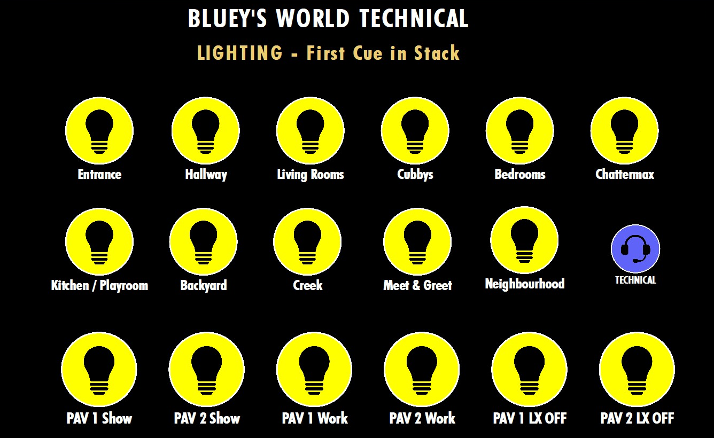

There are 4 types of buttons here. Work lights per pavilion, lights off per pavilion, show state per pavilion and individual show rooms.

The works lights for Pavilions 1 and 2 are simply a command to turn bright lights on across the whole precinct.

The other button is a work light off button. This turns lights off across the whole precinct.

Pavillion 1 and 2 show buttons will activate the first show state cue in each room

Finally, each room has a button to activate the first show state cue.

**Audio:**

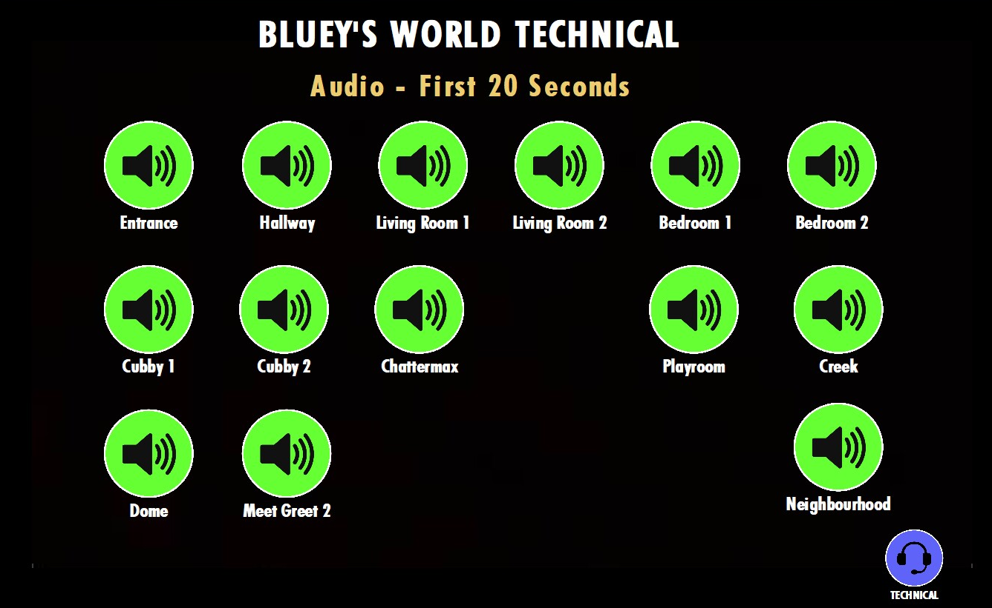

This panel controls audio testing in each room. It will play the first 20 seconds of audio only. This is good to ensure all speakers are playing.

**Vision:**

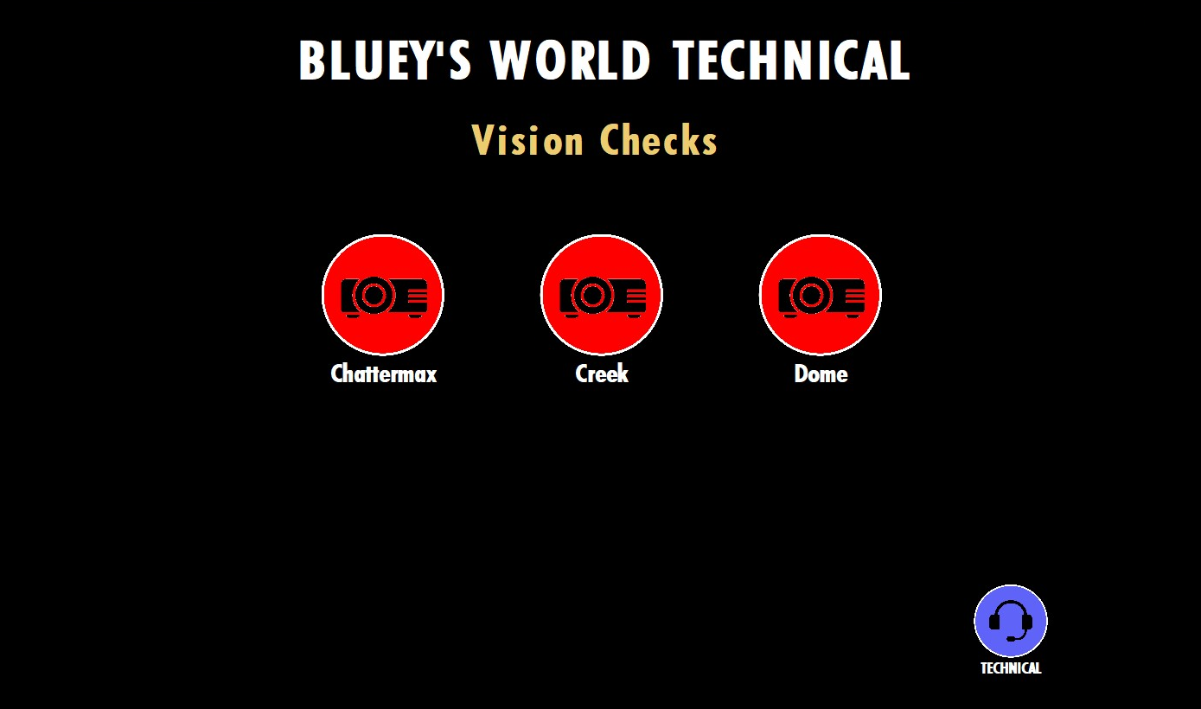

Here you will find vision checks. These checks are only to ensure the show control is properly sending messages to the projectors.

Please note, you will need to turn on projectors and ensure vision servers are running for this to happen.

**Automation:**

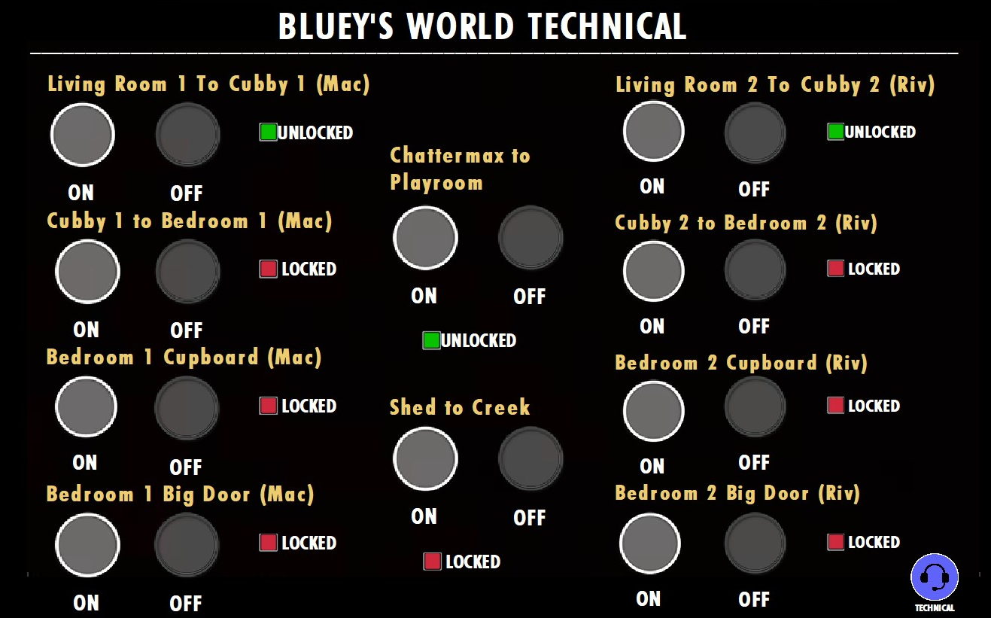

This page is where you will find buttons to control each rooms door locks. There will be an indicator to inform whether a door is locked or unlocked. Test each button and ensure the locks are working throughout the experience. These maglocks are directly controlled through the show system I/O modules. Please refer to the show system documentation for more information.

It is highly recommended that you take an iPad with you when testing the experience at the start of the day, especially when running the show.

**Operations:**

This show is designed to operate on its own. There are buttons starting the show which are carried out by experience staff members. The iPad will be set to Ops which gives an overview on what’s happening in each room.

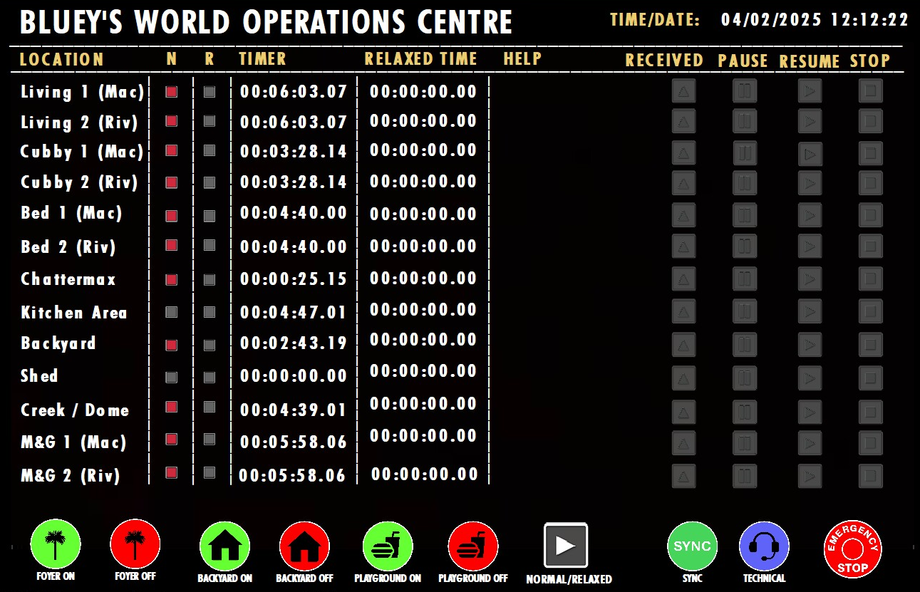

In this panel, you will find a list of every room in the show experience.

There is a column labelled “N” which indicates if a normal show is in operation and a column labelled “R” which indicated if a relaxed show is in operation.

There is a timer which will follow the start of each room. This is reset every time a room will start and will stop at the end of a room.

There is a help section which will indicate any alerts in each individual room. (Please refer to alerts section below for more information.

There are 4 buttons next to each room:

This is an acknowledge button to indicate that an alert has been observed by the technical team and clears the alert.

This is a pause function to pause a particular room. Please note that if you pause a room, every room before that will also pause to stop groups running into each other. You will also need to resume each room in reverse order to avoid this on restart.

This is a play and resume button. This is used to start a room if the show is not running, or to resume a room if is has been paused. This is for individual rooms.

This is a stop button. This stops the individual room completely. If you hit play this will go from the start.

Underneath the general overview of each room, we have some other buttons that control some overall audio in specific areas.

These are for foyer, backyard and neighbourhood. If you select the green button, they will turn on. If you select the red button they will turn off.



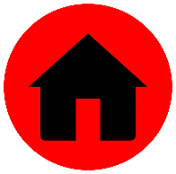

There are some more overall buttons for the precinct in the bottom left which include relaxed shows, syncing and emergency stops.



This button will take you to a panel where you can control if it is a normal show or relaxed show.

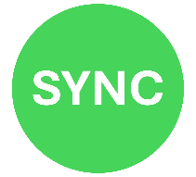This button will direct you to a panel where you can start the Living rooms, Cubby’s or Bedrooms in sync with each other. This would be most useful when restarting a show. Refer to Syncing below.

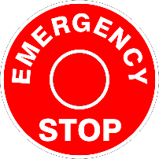

This button will direct you to emergency stop and audio muting sections. Refer to Emergency procedures below.

**Showtimes:**

During the show there will be an iPad in each room with a specific panel to each room. For this manual we will be using Bedroom 1.

The panel will default to a home screen which looks like this:



If you touch the screen anywhere, it will direct you to the home page which is where our communication screen begins. There are no unlock codes for if we have an emergency. We have identified that a logo with the words “Staff only” has significantly reduced the number of times curious people have attempted to push the buttons.



 Red Indicator – Sequence is not playing

 Green Indicator – Sequence is playing

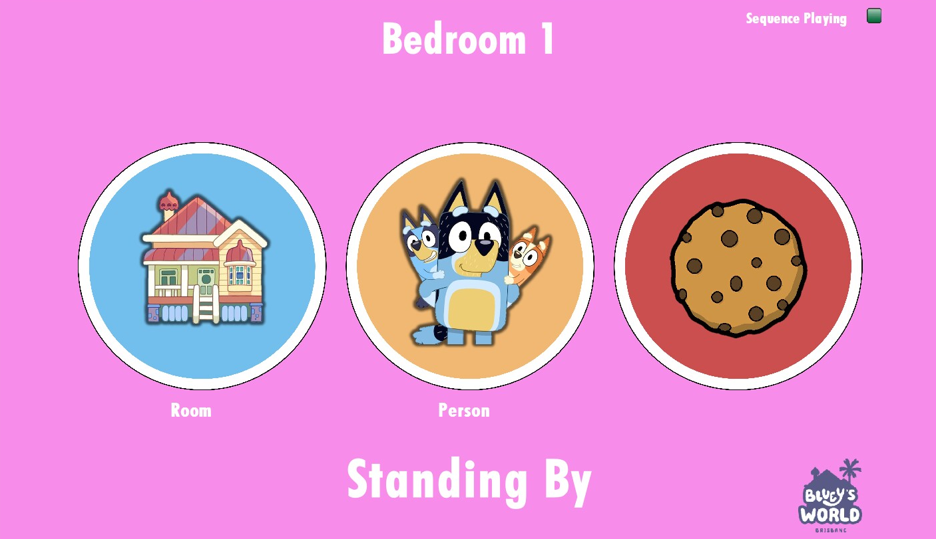

On this screen you will find the location for which room you’re in, an indicator to notify you if a sequence is playing or not, 3 large buttons for communication, a feedback text and a logo.

These buttons are used to communicate from Experience team to technical team about any issues that need resolving.

There are 3 different types of reasons for these buttons.

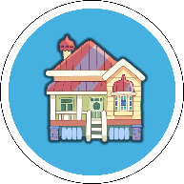

Room Alert - There is something wrong with the room or something has happened in the room.

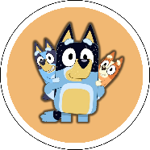

Person Alert – I need someone in the room.



Emergency – I have an emergency and need help asap.

Once you have selected the one you want, you will then be given an option of yes or no. This is essentially do you wish to continue with this command?

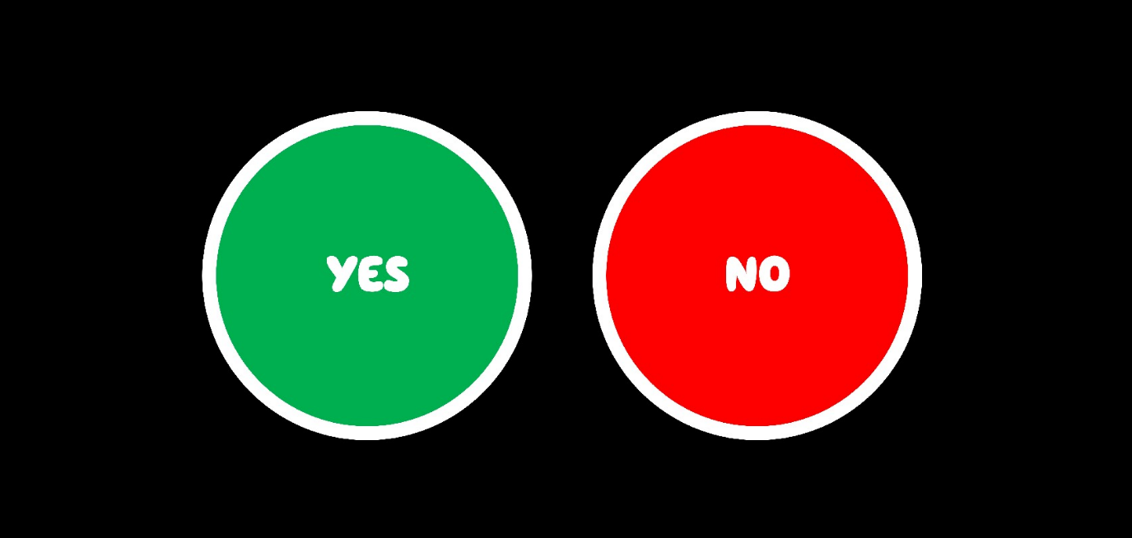

If you do, press the button yes. If you do not, press no.

When a button is pressed, this will notify an alert system to the technical team on their main Ops panel, an alert panel and back of house panel.

When a button has been pushed, the iPad will note that the button has been requested. When the technical team have acknowledged the alert, the iPad will report in the room “Received”.

*It is important to note that this is our way for effective communication whilst a character has no front of house or stage management in the room. The intended idea is for them to push a button to not break character. Our immediate response and action on the issue will help a performer not have to break character and ruin the experience. Please refer to the “Alert system response guide” for more information on how to communicate over radio to front of house, other technical team and management as required.*

**Alert Panel:**

In the operations room for this experience, we have a panel named Alert system. This is a black screen that will light up when there is an alert.

The screen will turn red, list the issue (room alert, person alert or emergency) and location. There is also a connecting buzzer that will make a sound and LED strip that will light up several times when an alert is made.

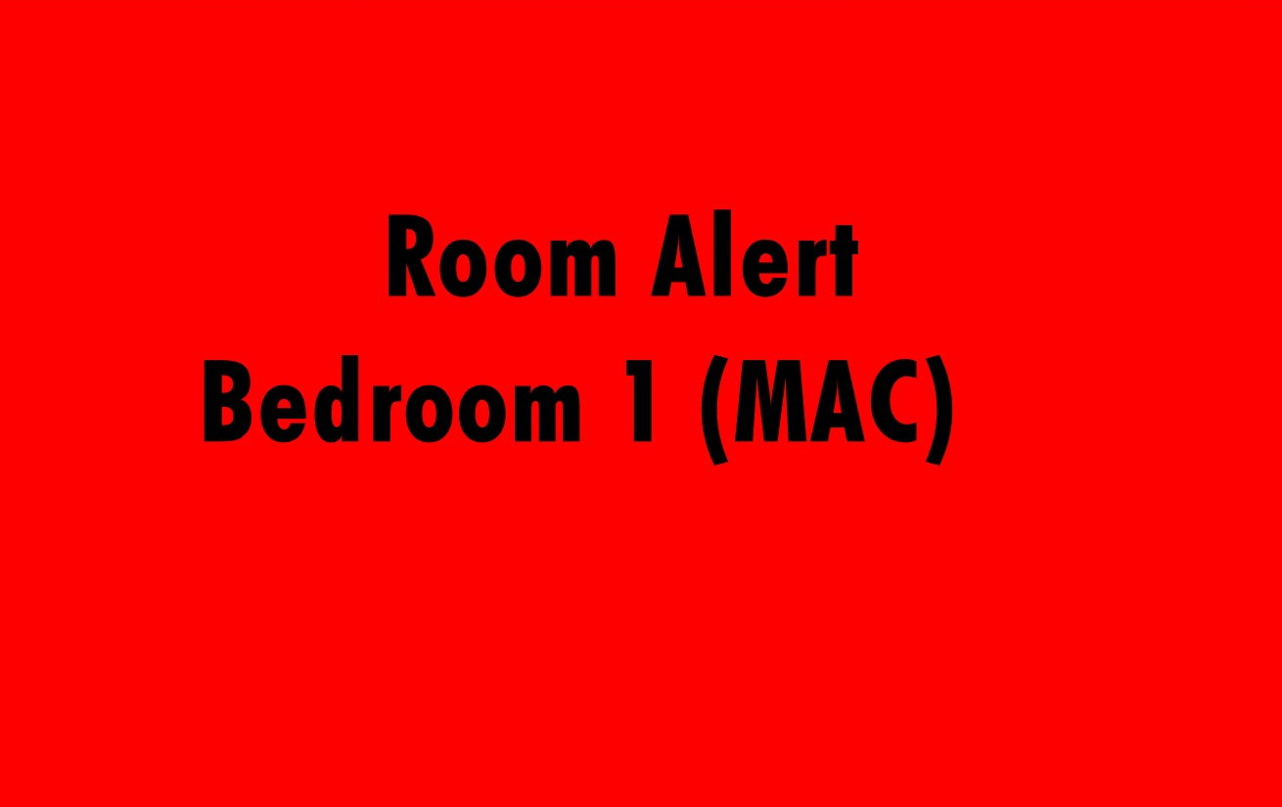In this example, Bedroom 1 has a room alert.

To clear an alert, you need to press the acknowledge button in the relevant room, located on the Ops panel.

**Relaxed Performances:**

In our commitment to be inclusive, Bluey’s World proudly offers relaxed performances. This can be an on-demand service without changing any show files over. The general idea of a relaxed performance from a technical point of view includes lowering audio levels and reducing the amount of effect lighting and flickering.

When you are running a relaxed performance, both sides of the experience need to be in relax mode. This is due to the groups merging from Chattermax onwards.

To operate a relaxed show, you can either push the red physical buttons in the entrance storage rooms or on the iPad.

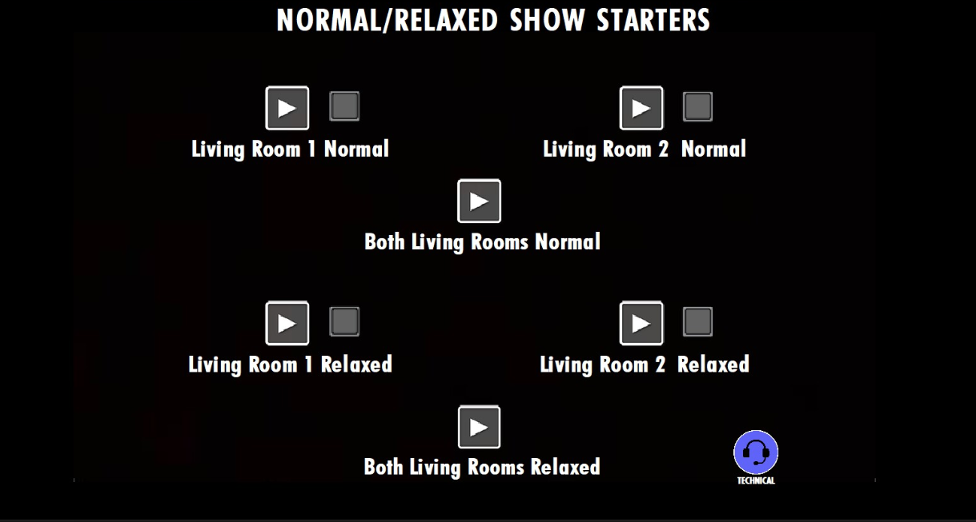

If you are running a show during the day, press “Both living rooms relaxed”.

The sequence will trigger certain levels of audio and lighting specific to each room. If you have a normal show following the relaxed performance 10 minutes later, that show will revert to its normal state.

To know what room is in a relaxed show, refer to the Ops panel where an indicator will light up what room is in Relaxed mode. The relaxed timer will also follow the rooms sequence.



Red Indicator – Sequence has been triggered

 Grey Indicator – Sequence has not been triggered

**Syncing:**

If we are required to start a show or restart a show, it is important that rooms before Chattermax are in sync with each other to avoid any overlaps on sequences. To do this we have a panel to sync the relevant rooms. They are living, cubby and bedrooms.

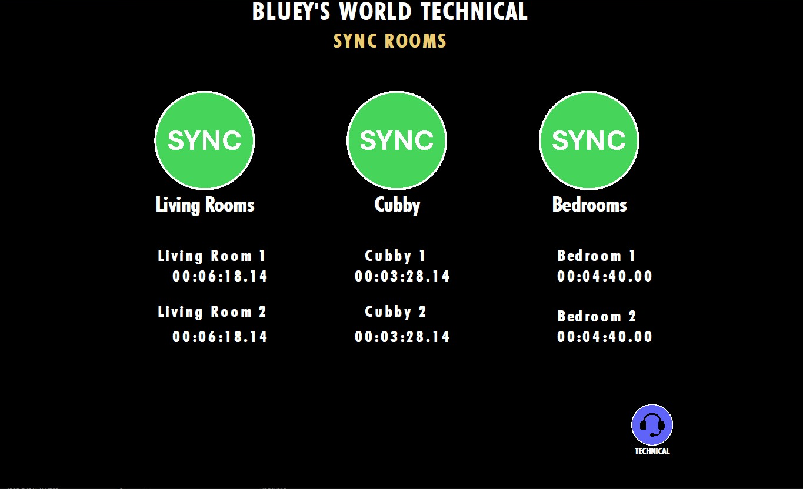

To Sync a room, simply push the green sync button above the rooms. This will trigger the start of the room.

**Show Audio Muting:**

This panel is found via Ops panel under Emergency Stop.

In here we will find 3 buttons for audio. Mute, Unmute and announcement.

Mute will mute all audio across the precinct, Unmute will resume audio across the precinct and announcement will be to activate a microphone for PA announcements.

It is important to note, that when an Emergency Stop has been activated, either annually or automatically via the Fire panel, the Audio will automatically mute. To unmute you will need to click unmute here.

**Pausing in a show environment:**

We have 2 types of pauses at Bluey’s World. One is a whole show pause, and the other is room pausing. Both systems are designed to pause the relevant rooms in place and resume once told to.

**Room Pausing:**

The first method is pausing a room. This system has been designed to avoid groups clashing with each other and gathering in single rooms. When you pause a room on the Ops panel, the system will also pause any room before it. For example, if you have a requirement to pause a bedroom, it will also pause the cubby and living room.

This system is designed to pause single sided rooms up to Chattermax and then whole experience pausing beyond that. This is because the show merges groups from Chattermax forward.

This will mean that if you pause bedroom 1, it will also pause cubby 1 and living room 1, however let the other side of the house continue through.

If you pause the creek, it will pause the backyard, playroom, Chattermax and both sides of the house. This is because the groups have already merged.

The purpose of this pausing is to enable groups that have already gone through to continue their experience.

To resume the rooms, press resume button on all the active rooms.

**Show Pausing:**

If there is a requirement for the entire show to pause, there is a button within the emergency Ops panel called “Pause Whole Show”. This panel is reached via the Ops panel by pushing Emergency Stop button.

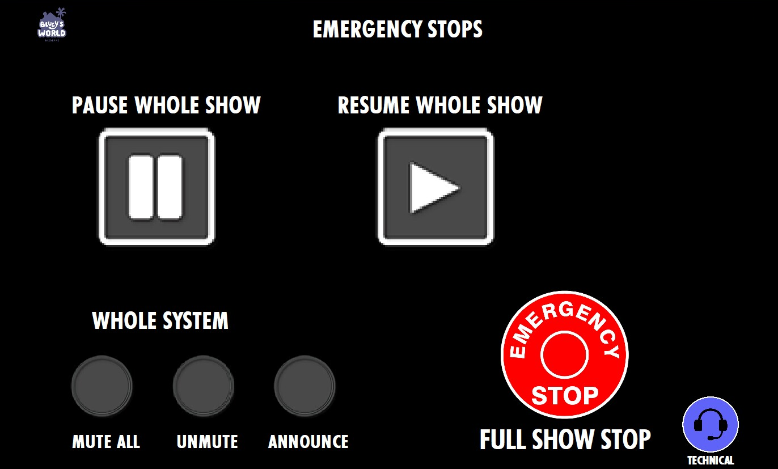

When you pause a show, the entire experience will hold in place and play a looping audio track of the grannies. Please note this will not impact any public areas including the front entrance and neighbourhood.

Once the issue has been resolved, you will push the “Resume Whole Show” button. This will play a 5 second audio clip and then resume the show as it was.

**Emergency Stop:**

This is for the operations on the iPad in an emergency. Please refer to emergency stopping procedures for departments.

A whole show emergency stop is designed to stop all sequences completely, mute audio and bring up emergency lighting. This stop can be done in 2 ways.

The first is a manual trigger which is by accessing the Emergency stop panel from the Ops panel.



When you push “Full Show Stop” (red button) it will activate the emergency protocols within the system.

The second way this is achieved is a closed loop triggered from the Fire Panel. When the fire panel detects something and is set into alarm mode, the Emergency system will automatically trigger the show stop from a technical point of view. The Fire Alarm will also sound on their own speaker system.

This emergency stop should only be used in an emergency and not to turn the show off at night.

It is important to follow the emergency procedures assigned to the technical team in an emergency.

**Resuming a show:**

Once an emergency stop has finished, we need to activate a few sequences to be show ready.

More to come